MANUAL rev. 1.2a

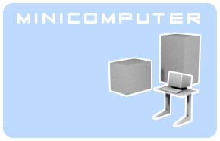

Minicomputer is an open source sound synthesizer for Linux, distributed under the GPL 3 license. It requires jack as an audio server and Alsa for midi connection.
Minicomputer is a stand-alone application, divided into two programs, the actual sound engine and the editor. Both independent programs communicate via OSC (open sound control) and it is possible to write different editors or control the engine from other applications which can talk OSC.

You can reach the original author at steiner@block4.com .
Regarding this modified version, write to marc.perilleux@laposte.net .

Table des matières
Installation 2
Getting started 2
Making sound 5
Compilation 9
Troubleshooting 9
OSC implementation 10

Installation
It's unlikely that you received Minicomputer from repositories of the Linux distribution of your choice. This means you have to compile it yourself, which is quite straightforward.
Your first step is to retrieve the source files for the version this documentation refers to from https://github.com/vloop/minicomputer-virtual-synth .
Compilation details are given in the compilation section and in the README file.
The executable files should normally be copied into /usr/local/bin.
The presets can be installed in your home directory by launching installpresets.sh.

Getting started
To start the synth you can type minicomputer at the command line. This will start the editor and the independent core if needed. The later will show up at for example top under the name minicomputerCPU. When you quit the editor with the close button on the window decoration, usually marked with an x, it will also shutdown the engine if it started it. Depending on your kernel settings for audio you might have to start the application core as superuser to access real-time performance and Jack.
The editor should find your home folder with the environment variable $HOME which is normally set in every Linux distribution. If it finds it, it creates the .miniComputer folder in which the setting files are kept. If you didn't use installpresets.sh you might want to copy the memory file with the presets in that folder to get started but don't forget to restart the editor to access them. The presets contain one demo multi and 32 sound presets plus 1 init preset. The later is good to start creating sounds from scratch and there is a single init file too which you can import anytime.
You can define the OSC network port with the command line parameter -port which is important when you want to run several instances of Minicomputer because the port has to be unique. Of course the editor and the engine need the same port to see each other, an example is for using the port 9000 instead of the default 7771. To minimize confusion in case of multiple instances, each one bears the port number in the name which is exposed i.e. visible on qjackctl. With this version, the core sends back some information to the GUI using the following port (default 7772). So for the next instance you'd specify at least -port 7773.
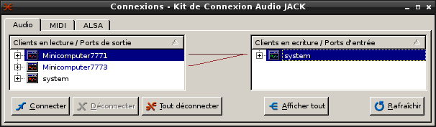
Well, it's software but under Linux with Alsa and Jack it's rather similar to studio environments so a diagram makes sense.

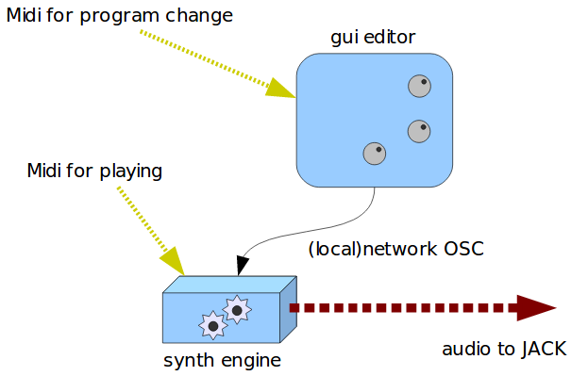

The editor talks to the sound core via Open Sound Control (OSC) protocol over localhost network, and the sound core reports status to the GUI over OSC as well. These two applications don't need to be connected manually and the order of launching doesn't matter, they should find each other. They communicate over the port 7771 which can be changed during compilation time in the common.h file or from version 1.1 on with the -port command line parameter during the start so you can run several instances of Microcomputer, see OSC implementation. Normally they reside on the same machine but it could be possible, with minor changes in the source code, that they run on separate computers, connected via network.
Both provide a midi port. The editor accept Midi program changes on channel 1 to 8 for switching between sounds. Since Midi allows only 128 programs, you need to send a bank select (cc=32, value=0..3) message first to access the 512 sound settings. On channel 9 you can switch between the 128 possible multi setups so all 8 voices can be changed at once to any of the 512 sounds, for instance at the beginning of a new song.

The synth engine receives note and performance data through its Midi port (Alsa or Jack midi), channel 1 – 8 for the individual voices.
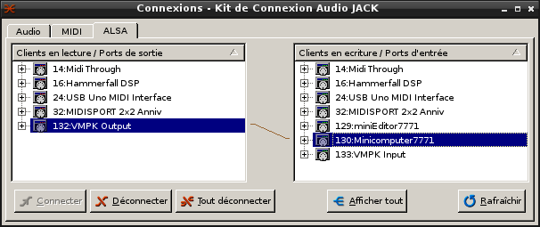
In addition, the current version responds to OSC /Minicomputer/midi followed by four integers. Current implementation supports note on, note off, all note off all sound off and control change messages.
The sound core provides several audio ports for JACK for the output of sound.
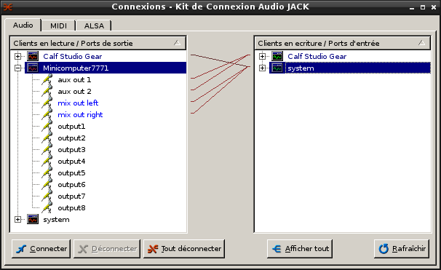
There is a stereo mixed output for mixing voices together, aux 1 and aux 2 as a separate two channel output, for instance for effects, and individual outputs for each voice.
Each voice has a knob for individual, aux 1, aux 2 and mix output volume, the mix is augmented with a dedicated panorama slider while the auxiliary panning needs to be done with the two volume knobs if desired. Otherwise they are meant to be separate outputs but its up to the user what to do with them.
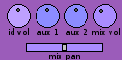
The volume settings are stored in the multi settings, not in the sound data.

Making sound
Minicomputer doesn't ape any existing synthesizer but has a rather traditional, subtractive approach and thus is easy to operate. Its made of 8 parallel voices forming a multitemperal setup, suited for example as a drum synth. Each voice is monophonic in itself so it can play only one key per time, additional triggers might cut off a sound of the same voice which was already on or fading.
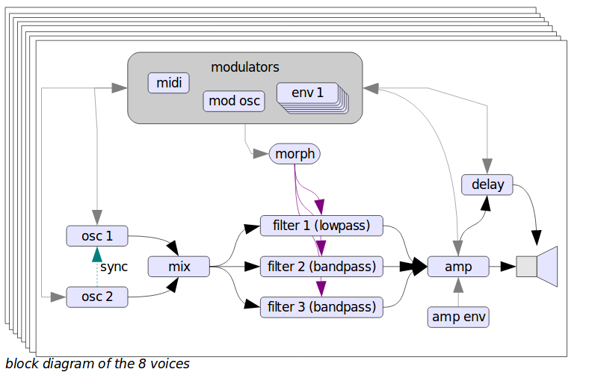
The synthesis based on the idea to create first a rather complex waveform via two oscillators which then get shaped with a complex morphing filter, actually made up of three filters. A low-pass filter (for not losing ground) parallel to two bandpass filters which shape further formants. The oscillators are not
band-limited which might lead to aliasing but give on the other hand a rich tone, important for the FM and amplitude modulation which can happen in both directions, even in the same time enabling feedback. The first oscillator has an extra sub oscillator. The second oscillator has slightly different features: it can be hard synced to the first one and the second amplitude modulator only modulates the FM output while the first one shapes the output volume.
Additionally there are more modulation options like another oscillator with a range going much into audio, the only difference that its not controlled by keyboard or pitch bending. Six envelopes of the traditional ADSR format are there for a lot of parameter changing, they can even turn into additional oscillators with the repeat button and reach also in the audio frequency range when speeded up. When in repeat mode, the attack and decay steps are always repeated, while release is repeated only if sustain is not zero.
A seventh envelope generator is routed to the amplitude of the output and is not available on other modulation destinations.
The sound choice of the eight mono voices can be stored into the multi setup which is handled separately. It's important to save your sound settings first and then the multi setting to make sure everything can be recalled correctly.
Minicomputer stores the sounds in a file called minicomputerMemory.txt, which can be opened in a text editor. Same goes for the multi settings which are stored in minicomputerMulti.txt. When the editor stores something to disk it writes it first to temporary files ending with .temp, then makes a backup of the former files to .bak and then finally commit the changes be renaming the temp files to the actual names. This is done for your convenience and safety and you shouldn't have files with the names mentioned above in the minicomputer directory, otherwise they'll get overwritten.
The 8 voices are arranged each on one individual tab and can be reached by mouseclick or keys F1 to F8.

The oscillator section features for each the frequency setting which can be set to a fixed value or coarse/ fine tuned, varied by the pressed Midi key. Tune is done with the XY crossslider, the horizontal is coarse in octaves while the vertical one is for fine tuning. Additionally for more precise control there is a display field showing the frequency value and accepts input from keyboard and mouse. Click on it and clickdrag to left and right for changing the value further. The three possible mouse buttons, left, right and middle click, change the value with a different factor. While all tuning crosssliders have such a numeric field, all other values can be fine tuned with the field near the logo. It changes the last tuned knob with the exception of these XY fields. This seems the best compromise between quick access and total control at the moment.
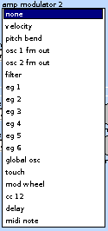
Waveforms can be chosen from a drop-down box. There are traditional forms like sawtooth and square, special ones for adding crackle noise (bit and spike), waveforms created with additive methods and 8 from Microcomputer, a non free Plug-in the original author programmed and offered some years ago for Windows and Mac OS9.
Modulation settings on Minicomputer consist of two GUI elements, a drop-down box for choosing the actual modulator and an amount dial going from 1 to 1. The negative amount changes the polarity of the modulator.
Where there are two modulation sources for the same destination, the two are normally added, however by checking the mult. box they can be multiplied instead. This is useful for varying a modulation using the modulation wheel on a MIDI master keyboard or for making an effect that varies with time, such as a progressive tremolo.

There are two slots for frequency modulation with the first one bearing a boost button to create extra harsh metallic sounds by boosting the modulation level 100 times. Two amplitude modulation slots shapes the
volume. At the first oscillator they both control the volume at the output to the mixer and the separate FM output which becomes a modulator while at the second oscillator only the first slot does so, the second forms only the FM output so more complicated blending can be done. Also only at the second one there is a sync button to hard-sync it to the first one, so the phase gets restarted when the first oscillator resets its phase. The oscillators can also modulate themself, creating interesting chaotic feedback behaviour. In case of some modulation, particular the boosted FM, go out of control, you can reset the internal signal path with the button in the filter section. It doesn't change settings but effect the whole internal signal path for that voice.
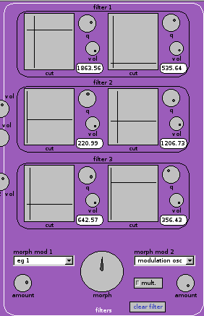
The morphing filter consists of three distinct filters in parallel, each with settings for cut-off frequency, q which means resonance and volume with positive and negative polarity. These settings are there two times and you (and/ or two modulators) can blend between them with the big morph knob for all 3 filters at once. When you use modulators, the morph dial acts more as an offset so experiment with the modulation amounts and morph setting to get the desired effect like filter sweeps or formant morphs.
The frequency is here again to be set with the XY crossslider like above mentioned and also features a separate display for fine tuning.
Be careful with the resonance settings because this can lead to harsh distortion. The original author ripped once a hi-fi speaker with a Korg MS 20 analog synthesizer in 1986, this can actually happen! (Not to mention ear damage) However he decided not to scale down that much the resonant signal because it's important for creating formant peaks. Anyway there is some scaling involved to protect a little bit, otherwise the filters would roar, tear and rip much earlier.
The Esc key acts as a panic button, sending all sound off messages to each voice.

Next to the filter there are the modulators with the 6 free routable envelopes and the independent modulation generator. The envelopes can get quite fast and act as modulation oscillators too when switched in the autorepeat mode with the repeat button. Otherwise they are are pretty oldschool with a conservative attack, decay, sustain and release (a.d.s.r.) approach.

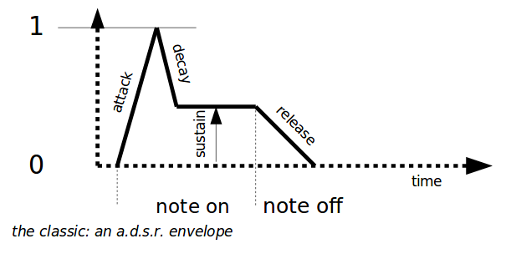

Further to the right there is the amp section with one modulation slot (for instance modulating the volume by the velocity of the pressed key) and a dedicated envelope generator.
The pan position can also be modulated, for ping-pong or other effects.
Also on the right there is a delay for each individual voice, whose settings are stored along the sound data. The delay time can be modulated which creates some interesting effect inclusive flanging and feed-backed pitch shifting. The output of the delay is also available as a modulator. The original author tried it also as a feedback audio source but the results were not that interesting.

On the footer there is the memory section which allows the storage and recall of sound and multi settings. Multi stores only the sound choices of each voice and the volume section whose knobs have a different colour code.
You can choose a sound or multiprogram with the large horizontal wheels underneath the name fields which are handy with the large list of settings. After choosing a setting you have to press the load buttons for actually loading it (i.e. applying the sound parameters). The store button writes the current settings to that storage location and you can give it a new name in the field before pressing that button.
The digits show the memory location and are helpful for finding out the numbers for a remote program change.
To exchange sounds with others you can import or export individual sounds to separate text files, whose names you can choose freely. The in/export goes in and from memory directly, you can only export a saved sound or import to a certain memory location. The memory location doesn't need to be loaded, it is sufficient to have it dialled. After importing you need to load that sound with the load button to actually play it.
There is an audition button for quickly checking the currently loaded sound without connecting a (physical or virtual) keyboard. Beware this is the currently loaded sound, which may be different from the one displayed in the memory controls.

MIDI settings
On the MIDI tab, for each of the 8 voices, one can select the midi channel, the lowest note the voice will respond to, and the highest. These parameters, together with the test note number and velocity (which will sound when « audition » is pressed), are saved in the multi, along with the volume settings. The midi parameters apply to Jack and ALSA inputs, but not to the OSC input. This features allows the « audition » button (sent as an OSC message) to always trigger the current voice, no matter what its midi settings are.
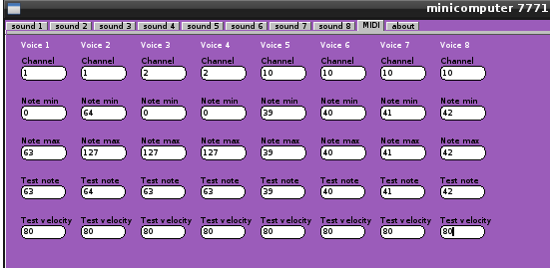
In the above example, the keyboard is split between voice 1 and voice 2 over channel 1, voices 3 and 4 are stacked on channel 2, and voices 5 to 7 respond to specific notes on the percussion channel (10), so they can be controlled easily from a rhythm box like Hydrogen.

Compilation
Dependencies include:
– Jack
– FLTK guitoolbox for editor
– Alsaseq for Midi communication
– pthreads
– liblo for OSC communication
and
– Scons for building

The engine is written in C and have its source code in the cpu folder and the editor is in C++ with the source files in editor. Parameters for customization are in the common.h file.
To build Minicomputer just type scons at the command prompt.
Yet missed is an installation routine so put the files anywhere you need them.
Cleaning the build files but the new created program files TOO, is done by typing scons -c.
Installation in /usr/local/bin can be done as superuser/root with a bunch of preset sounds can be installed to the .miniComputer directory in your home folder with the script installpresets.sh should be there any previous settings, they got backed up.
The buildprocess accept parameters for refining architecture optimization:
– 64bit=1
forces a build for 64bit platforms with the m64 option
– k7=1
optimizes for AMD AthlonXP processors
– k8=1
optimizes for AMD K8 cpus, giving the compilers the march=k8 mtune=k8 settings.
The common.h file have more customizable parameters. You can switch on debugging messages by uncommenting the line //#define _DEBUG.
The original author tried a vectorized version for improving performance but it didn't improve it at least on his hardware which was AMD cpus only. For experimentation you can uncomment //#define _VECTOR.
There are other switches like the 'old' binary file format but that use is discouraged now because it certainly will lead to wrong behaviour.

Troubleshooting

'I have library xyz installed but scons complains about not finding xyz'
- make sure that you have the developer version of the library installed which comes extra and additionally. Usually looks like libxyz.dev
It's the original author's first project with scons and he experienced the following bug: when he gave wrong parameters for gcc, scons complained about not finding a library although it's there. This could be a reason too.

OSC implementation
The core accepts messages from the editor in the OSC protocol. The port is 7771 as default which can be changed in the common.h file for building alternative versions. One port accept only one editor so its not possible to run several instances of Minicomputer without building alternative versions or specifying a different port for both applications with the parameter -port during starting.
The following messages are sent via OSC:
For multiple choices the message is /Minicomputer/choice followed by three integers, the first one denotes the voice number, the second the number of the choice parameter and the last one the actual value.
Other parameters are sent as /Minicomputer and two integers and one float. First integer says which voice, the second the parameter index and the last one the actual value as a float.
The following diagram is overlaid with the OSC parameter numbers:
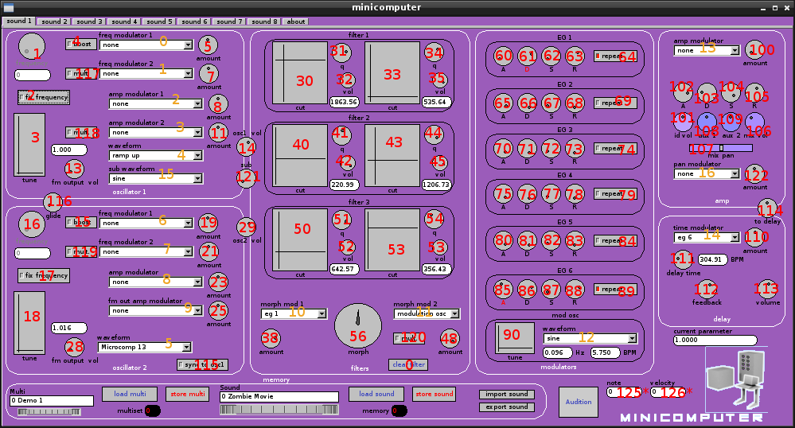
Please bear in mind that the drop down boxes have their own numbers (in orange) which are transferred as /Minicomputer/choice with three integers as stated above. Pseudo-parameters note and velocity are not transmitted, they are used by the GUI when the audition button is pressed.

